

Submitted by:

Jonathan Q. Barasi

Lois Anne G. Logronio

Katharyn Alexandre D. Mayo

IT-111

Submitted to:

Mr. Manuel Sean Sanchez

Table of Contents

3……………………………………….Background of the Company

4……………………………………………..…. General Objectives

5…………………………………………..……. Specific Objectives

6…………………………………………………….…. Event Table

7………………………..…………………………………..Glossary

Background of the Company

Journeys & More Global Tours and Consultancy Co.(JMGTC) is Philippines travel bureau engaged in international and local ticketing, hotel reservation, worldwide tour packages, domestic island tours, corporate travel plans and customized travel arrangements. They specialize in adventure and off-the-beaten path tourism and travel activities.

Journeys & More began its humble operations as a ticketing agent and travel consultancy outfit providing consultancy and documentation services to Filipinos and foreigners alike here and abroad.

Their office is now the Metro Manila Visa Assistance Center, helping local and international with legitimate and verifiable visa applications and all other related documentation processing and consultancy services.

Journeys & More connects travel newbies and veterans alike with professional service providers of quality tours and accommodations that fit each traveler's wish and budget.

They are open on Monday to Friday 9:00am - 6:00pm Saturday 9:00am - 3:00pm

3

General Objectives

* Get more clients from all around the world
* Provide an easy to use application for booking or reserving
* No more time consuming on going to the office
* Lessen the work of Travel agents and Booking agents

4

Specific Objectives

• To create or design a booking/reservation system for clients all around the world

• To promote the system through the website and sharing it with other people

• To design a system that will be less time consuming for the clients and booking agents as well

• To provide clients with airlines and dates when they want to book a flight

• To provide clients to book their ticket in any time or place

5

Event Table

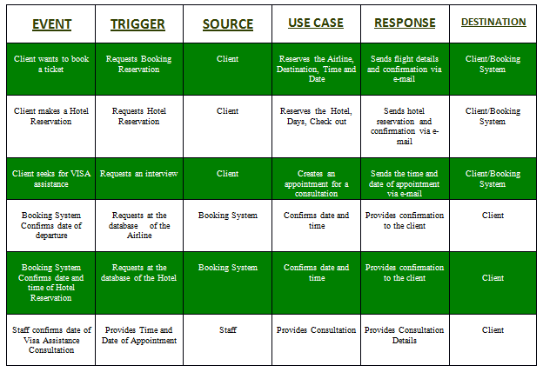

6

Glossary

* **Travel**-movement of people or objects (such as airplanes, boats, trains and other conveyances) between relatively distant geographical locations.
* **Travel Agency**-private retailer or public service that provides tourism related services to the public on behalf of suppliers such as airlines, car rentals, cruise lines, hotels, railways, and package tours.
* **Booking Agent**-someone who engages a person or company for performances.
* **Airline**-is a company that provides air transport services for traveling passengers and freight.
* **Client**-is the recipient of a good, service, product, or idea, obtained from a seller, vendor, or supplier for a monetary or other valuable consideration.
* **Airline Ticket**-a document, issued by an airline or a travel agency, to confirm that an individual has purchased a seat on a flight on an aircraft. This document is then used to obtain a boarding pass, at the airport.
* **Reservation**-The act of reserving; a keeping back or withholding.
* **Hotel**-an establishment that provides lodging paid on a short-term basis

7